2021 Annual Conference
Dreams Los Cabos – Important Details
The time has come to unveil the exciting details regarding the 2021 DIA Annual Conference! As previously announced, it will be held April 21st to 24th, 2021 at the Dreams Los Cabos resort. This is an all-inclusive resort, providing unlimited eating, drinking, and service! We have an exciting program lined up for you, and I will take time to detail that in future emails...for now, let's talk Cabo!
Because we are hosting our first truly international conference, there will be some deviations from our previous meetings. Dreams will be a lovely venue that will treat you wonderfully! Attached is a brochure that goes into detail about the resort. The DIA will also be providing your transportation to and from the airport via Tropical Incentives as part of your sponsorships. I got to know them while I was scouting in Cabo. I feel safe that you will be taken care of as you land in Mexico and make your way to our resort, just 40 minutes away, and on the beautiful Pacific shores of the Baja California Peninsula.
Once you arrive at the resort, a personal host will check you in. Once checked in, please visit our hospitality table (by Tropical Incentives), where you can review and sign up for some amazing activities to enhance your stay and pick up your welcome bag. From that point on, the staff of the Dreams Resort will be there to make sure you have everything you need!
Very Important!
- Shipping – if you choose to ship anything, you MUST use a broker – the Baja Peninsula is much different than eastern Mexico.
  - I will provide the contact should you need it. They are well versed in the laws, much more than FedEx, UPS, or DHL. Those shipments always get stuck at the border.
  - If you need to ship, you must send the package at least one month in advance.
  - If you can carry it on the plane, that is the easiest option.
  - If you want to send me anything for the welcome bags, please contact me for the Broker info.
- You MUST notify me and Tammy at fairielandtravel@brighthouse.com of your flight information so that we can coordinate your transfers from the airport to the resort.
- Passports - get 'em! It's 2021, and everyone should have a passport. It's easier than you think, and they're valid for 10 years! (5 years for children under 16.)
- MORE-

- Reservations:
  - In the past, many have waited to reserve your room, and that has been ok. However, not the case here at Dreams. All reservations must be made and paid by February 14, 2021.
  - Also, in the past, a few have been able to reserve their rooms through alternative means. This is not the case this year, either. Reservations must be made directly with the resort. We have worked hard at getting the numbers to align with what we need and what the resort will accept. Every room counts! If rooms are not reserved through the resort, they do not count for the DIA.
You can review the brochure with rates and information on the Dreams Resort. While you're there, we encourage you to enjoy Mexico and do it safely by using our provider Tropical Incentives for any off-resort activities. Your safety is my priority! Also attached is a PDF of some outside activities you may want to partake in (I can highly suggest the sunset cruise!) - come in early, stay late! This is a great time to combine our important work with a whole lot of fun. Bring your family!
As a special thank you for attending this extraordinary event, we will be offering a discount of $100 per single and $150 per double room for the nights of the conference only (Wednesday – Friday). This will help offset the AI fees to be more in line with our previous rooms’ costs.
If you plan on being a partner this year, please email Michelle Hambidge @ michelle@dentalintegrators.org with your desired level. The collateral and website will be updated soon, for registration & payments.
Please book your rooms by the official hotel website: https://www.dreamsresorts.com/en_us/resorts/mexico/los-cabos.html and use the contracted the group code: 20DIACON
Click the Book Your Getaway in the top right corner, choose your dates (Our rates are available as early as Saturday, April 17th), and click Resort Only.

- MORE-

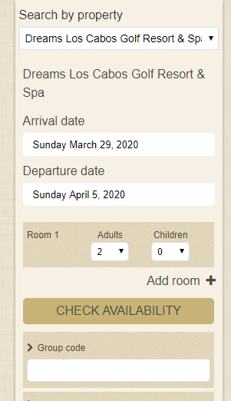

Change the number of people and add rooms if you need to, then in the Group Code box enter 20DIACON, and click Check Availability. This will open a new page with our rooms and room rates.

As always, I am here to help answer any questions, and I can pass along all your travel questions to our travel advisor, who can make sure your trip goes off seamlessly.
I can’t wait to SEA you all there!
Warm Regards,

Michelle Hambidge
Director of Marketing & Administration

