**2021** **DIA Annual Conference**

SAVE THE DATE

**April 21-24, 2021**

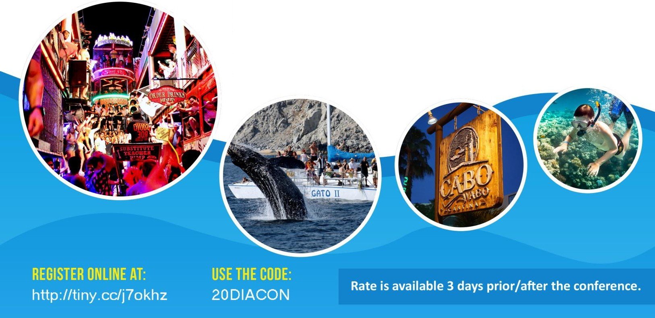

***Dreams Los Cabos, Mexico***

*(All-Inclusive Resort)*

**All rooms must be booked and paid by 2/14/21**

**Flight information MUST be submitted for airport transfers**